Rainfall Prediction Dashboard

Visualization Part:

* Sheet 1:

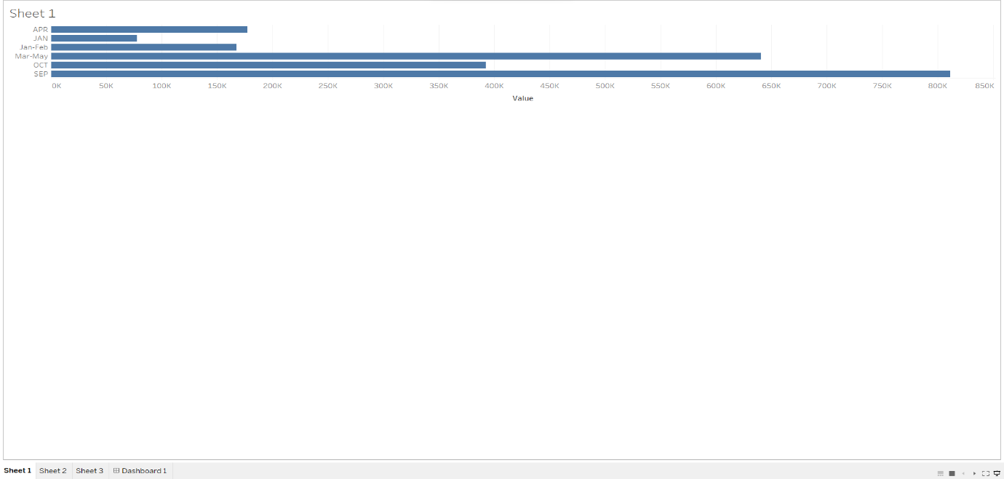

* Sheet 2:

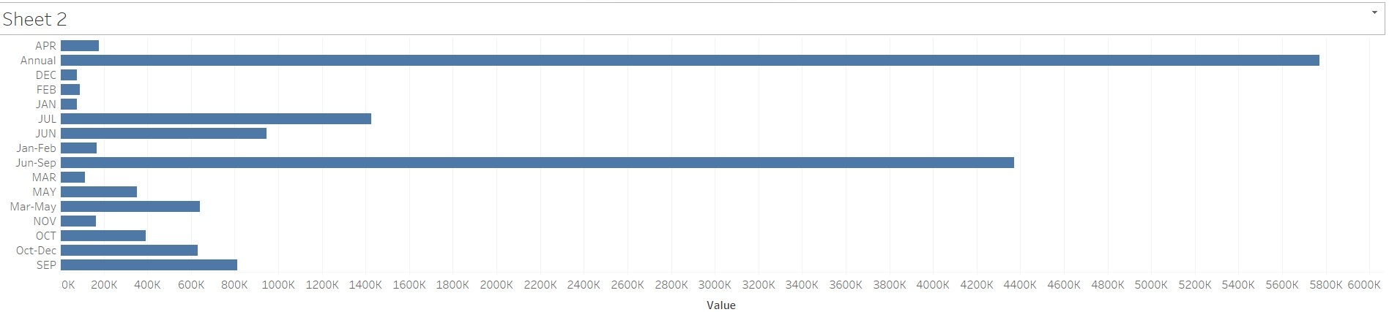

* Sheet 3:

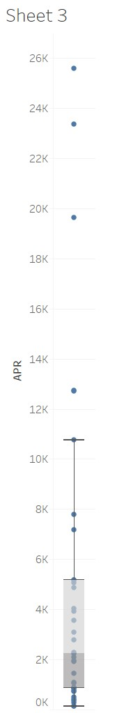

* Sheet 4:

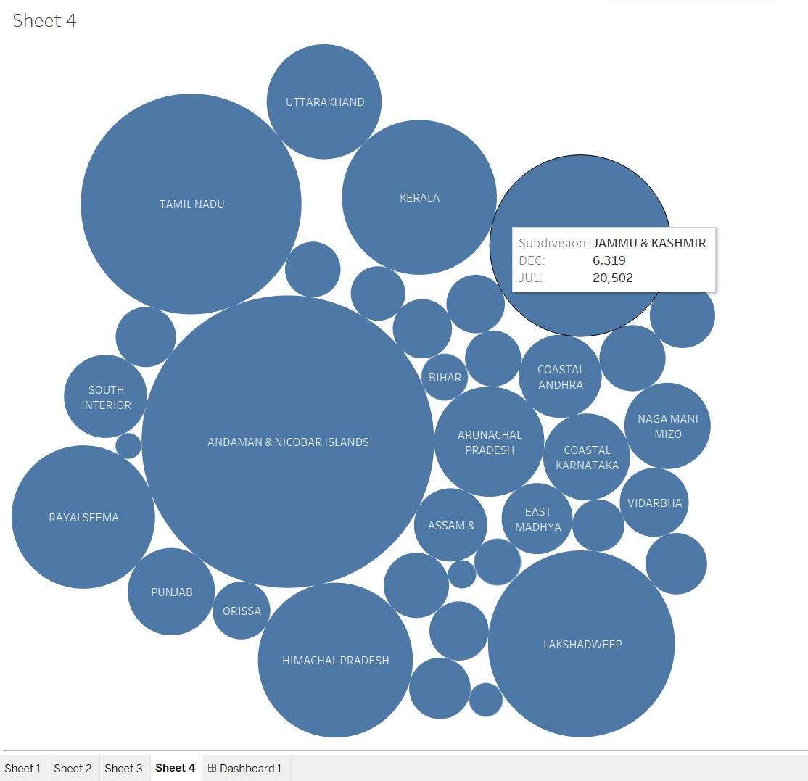

* Sheet 5:

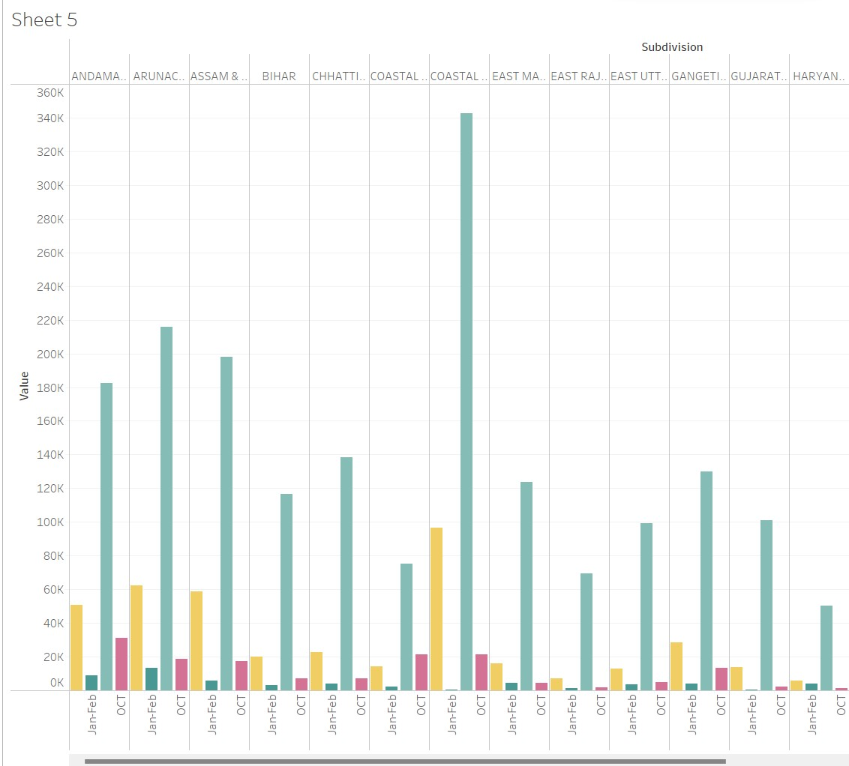

Overall Sheets:

